**Experiment No : 3**

Name : Rajashri Jaywant Patil

**Title : Clauses in Mysql.**

**A.Create Databases :**

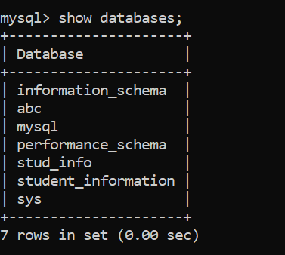

**B.Use Database :**

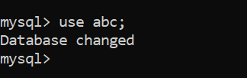

**C. Create Table :**



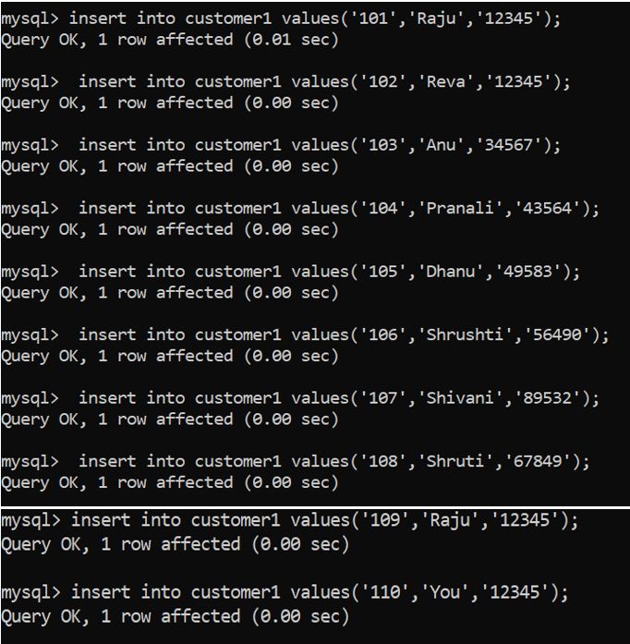

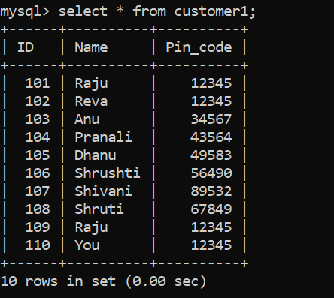

**D.SQL Clauses :**

**1.WHERE :**

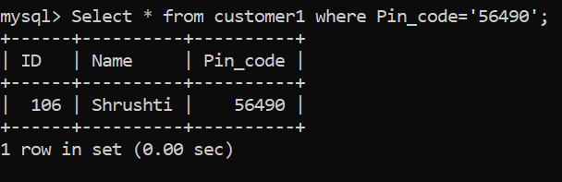

**2.ORDER BY :**

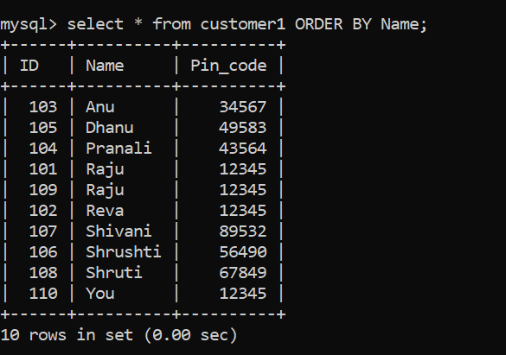

**3.GROUP BY:**

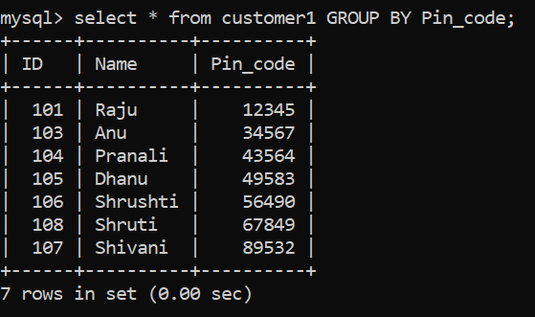

**4.HAVING :**

